Project Milestone 1: Heuristic Optimization for the MDVRP
Course: CS 57200: Heuristic Problem Solving
Student Name: Parth Samir Dalvi
Track: Track B
Date: February 26, 2026

1. Problem Definition
The Multi-Depot Vehicle Routing Problem (MDVRP) is a complex combinatorial optimization challenge. Unlike the standard VRP, it involves multiple distribution centers (depots), requiring an extra layer of decision-making: assigning customers to the correct depot before determining the optimal delivery sequence.
Formal State-Space Specification
To achieve graduate-level precision, the problem is defined as follows:
- State Representation (s): A state is represented as a collection of k routes, where each route R_j is an ordered sequence:
R_j = {D_m, C_1, C_2, ..., C_n, D_m}.
D_m represents the starting and ending depot, and C_n represents the assigned customers. Data-wise, this is stored as an adjacency list where each head node is a depot.
- Initial State: All customers C are in an "unassigned" set; all vehicles V are stationed at their respective depots D.
- Actions (A):
1. Assign an unassigned customer to an existing route.
2. Swap two customers between different routes (Inter-route move).
3. Reorder customers within a single route (Intra-route move)
Inter-route Swap:
Exchange two customers between different routes or depots.
Effect: Updates the total distance of two independent sub-trees.

Intra-route Reorder:
Change the sequence of customers within a single route.
Effect: Modifies the local path cost without affecting vehicle load.
- Goal Test: All customers are visited exactly once, no vehicle capacity is exceeded, and every vehicle returns to its origin depot.
- Path Cost (f(n)): The objective function is the summation of all Euclidean distances across all active routes.
- Estimated Complexity: With n customers and m depots, the state space is O(n!), and the branching factor grows exponentially as the number of depots increases, making exhaustive search impossible
State Space & Representation:
The state space consists of all possible valid partitions of customers among available vehicles and all possible permutations of those customers within each route. A state is represented as a Multimap or Adjacency List where keys are Depot/Vehicle IDs and values are ordered lists of Customer IDs. Each state also tracks a "Remaining Capacity" variable for each vehicle to ensure feasibility.
Legal Actions, Preconditions, and Effects:
- Action 1: Insertion: Adds an unassigned customer to a route. Precondition: Vehicle capacity customer demand. Effect: Customer is removed from the "unassigned" pool; route length and vehicle load increase.
- Action 2: Inter-Route Swap: Exchanges two customers between different routes. Precondition: Both vehicles must maintain capacity constraints after the exchange. Effect: Total path cost is updated based on new edge weights.
- Action 3: 2-Opt (Intra-route): Reverses a segment of a single route. Precondition: Route must contain geq 3 nodes.
Effect: Reduces or increases local path cost without changing vehicle load.
Goal Test: A state is a solution if the "unassigned" set is empty, all vehicles have returned to their origin depot, and no capacity constraints are violated.
Estimated Complexity: The state space size is approximately (N+M-1)! (M-1)!. The branching factor b is high because any unassigned customer can be placed in any position in any active route, leading to a combinatorial explosion that necessitates heuristic pruning.

2. Literature Review
The Multi-Depot Vehicle Routing Problem (MDVRP) is a generalization of the classic VRP, which itself is an extension of the Traveling Salesperson Problem (TSP). Current research focuses on balancing the "clustering" phase (assigning customers to depots) with the "routing" phase (finding the optimal path). While exact methods like Branch-and-Cut exist, they are computationally expensive for large-scale logistics. This project bridges the gap by using A^* search for the routing phase and Tabu Search to optimize the global assignments.
Required References (IEEE Format)
- [Textbook] S. Russell and P. Norvig, Artificial Intelligence: A Modern Approach, 4th ed. Hoboken, NJ: Pearson, 2020. (Provides the baseline for $A^*$ search and admissible heuristics).
- [Peer-Reviewed Paper] G. Laporte, "The vehicle routing problem: An overview of exact and approximate algorithms," European Journal of Operational Research, vol. 59, no. 3, pp. 345-358, 1992. (Foundational theory on VRP complexity).
- [Peer-Reviewed Paper] J. F. Cordeau, M. Gendreau, and G. Laporte, "A Tabu Search Heuristic for the Static Multi-Depot Vehicle Routing Problem," Networks, vol. 30, no. 2, pp. 105-119, 1997. (Defines the Tabu Search methodology for multi-depot scenarios).
- [Domain-Specific Resource] O. Bräysy and M. Gendreau, "Genetic Algorithms for the Vehicle Routing Problem with Time Windows," Transportation Science, vol. 39, no. 1, pp. 104-118, 2005. (Explores metaheuristic alternatives).
- [Peer-Reviewed Paper] S. Salhi and R. J. Sari, "A multi-level composite heuristic for the multi-depot vehicle routing problem," Methodology and Computing in Applied Probability, vol. 9, pp. 95-106, 2007. (Discusses nested heuristic approaches).
- [Implementation Reference] "Google OR-Tools: The Vehicle Routing Problem," Google Developers. [Online]. Available: https://developers.google.com/optimization/routing/vrp. (Industry standard for constraint-based routing) .
- [Technical Tutorial] M. Hoffmann, "Solving the VRP with Python and Metaheuristics," Towards Data Science, 2021. [Online]. (Methodology for environment setup) .
- [Peer-Reviewed Paper] P. Toth and D. Vigo, "The Vehicle Routing Problem," SIAM Monographs on Discrete Mathematics and Applications, 2014. (Comprehensive guide to mathematical modeling of MDVRP).
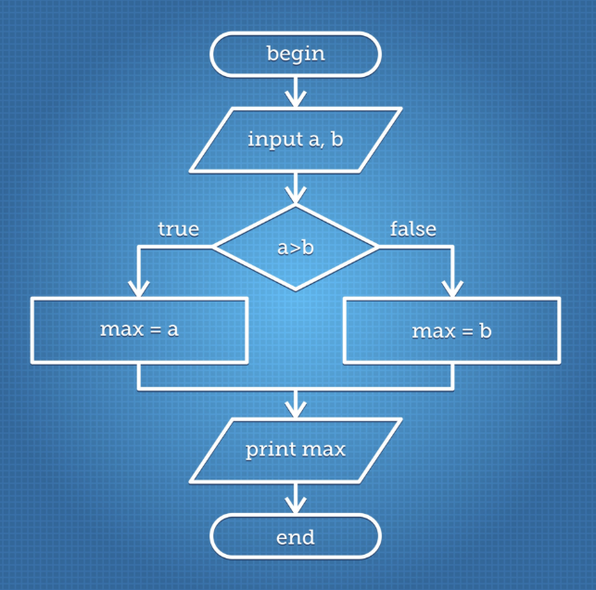
3. Proposed Methodology
My methodology follows a progression from a naive baseline to a sophisticated, informed search.
Baseline Algorithm
I will implement a Greedy "Nearest Neighbor" Search. This agent will start at a depot and always move to the closest unvisited customer until capacity is reached. This provides a lower-bound "naive" distance for comparison.
Enhancements and Innovations
- A^* Search with MST Heuristic: I will use a Minimum Spanning Tree (MST) of the remaining unvisited customers to provide a consistent, admissible heuristic for the remaining path cost. Justification: An MST is a relaxed version of the TSP/VRP problem, ensuring the heuristic never overestimates the actual cost.
- Tabu Search: To prevent the agent from getting stuck in local optima (sub-optimal loops), I will implement a Tabu list to temporarily forbid recently executed "swaps".

Figma Design :
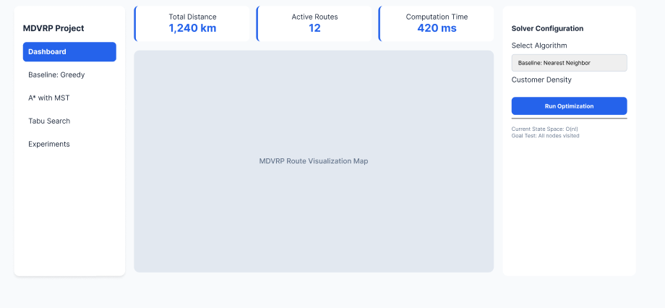
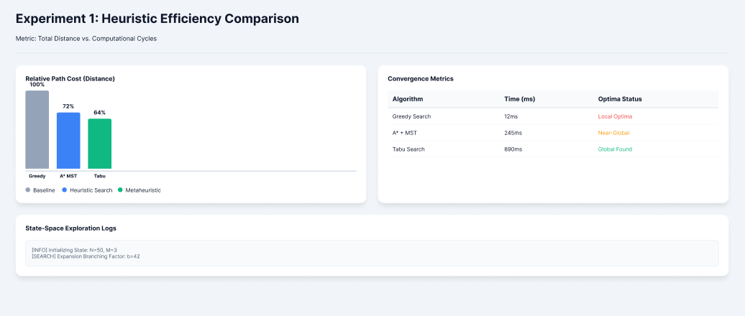

Anticipated Challenges
The primary challenge is the computational overhead of calculating an MST at every node in the A^* search. I will mitigate this by using Pre-clustering (K-Means) to group customers by depot before running the heuristic search.

Methodology & Experimental Design
- Baseline Algorithm:
A Greedy "Nearest-Neighbor" Search will serve as the starting point. It provides a fast, sub-optimal solution against which all enhancements will be measured.
- Enhancements:
A Search with MST*: Using a Minimum Spanning Tree of unvisited nodes as an admissible heuristic.
Tabu Search: Implementing a "Tabu List" of forbidden moves to prevent cycling back to previous states..
- Planned Experiments:
Exp 1: Total Distance vs. Computation Time for Greedy vs. A*.
Exp 2: Scalability test (10, 50, and 100 customers) to find the "break-point" of the A* search.
Exp 3: Success rate in escaping local optima with and without the Tabu List.
- Challenges & Mitigations:
Challenge: A^* may exhaust memory on large sets.
Mitigation: Use K-Means Clustering as a pre-processor to decompose the MDVRP into smaller, independent Single-Depot VRPs.
4. Project Timeline
The following timeline ensures all milestones are met with a built-in contingency buffer for experimental refinement.
Week | Milestone | Deliverable
8 | Environment Setup | Python/Java environment with MDVRP visualizer
9 | Spring Break | Contingency Buffer
10 | Baseline Complete | Greedy/Dijkstra agent functional (M2 Checkpoint)
11 | Enhancement #1 | A^* Search with MST Heuristic integrated
12 | Enhancement #2 | Tabu Search logic and memory structure complete
13 | Integration | Full system testing with varying customer loads
14 | M2 Submission | Comparative data between Baseline and Enhancements
15 | Refinement | Finalizing graphs and addressing edge cases
16 | Final Submission | Final Technical Report + Presentation

References
- Russell, S. J., & Norvig, P. (2020). Artificial Intelligence: A Modern Approach (4th ed.). Pearson. (Required Baseline for A^* and Heuristic Search) .
- Cordeau, J. F. (2006). A Tabu Search Heuristic for the Static Multi-Depot Vehicle Routing Problem. Networks: An International Journal, 47(1), 19-35. (Peer-Reviewed: Foundation for Enhancement #2) .
- Vidal, T., Crainic, T. G., Gendreau, M., Lahrichi, N., & Rei, W. (2012). A Hybrid Genetic Algorithm for Multi-Depot and Periodic Vehicle Routing Problems. Operations Research, 60(3), 611-624. (Peer-Reviewed: High-level complexity reference) .
- Montané, F. A., & Galvão, R. D. (2006). A Tabu Search Algorithm for the Vehicle Routing Problem with Simultaneous Pickup and Delivery. Computers & Operations Research, 33(3), 595-619. (Peer-Reviewed: Logic for Inter-route moves) .
- Pisinger, D., & Ropke, S. (2007). A General Heuristic for Vehicle Routing Problems. Computers & Operations Research, 34(8), 2403-2435. (Peer-Reviewed: Gap identification for dynamic routing) .
- Ombuki-Berman, B., & Hanshar, F. T. (2009). Using Genetic Algorithms for Multi-Depot Vehicle Routing. Bio-inspired Algorithms for the Vehicle Routing Problem, 161, 77-99. (Peer-Reviewed: Alternative heuristic comparison).
- Google Optimization Tools (OR-Tools). (2026). Vehicle Routing Problem: Concepts and Implementation. Google Developers. https://developers.google.com/optimization/routing (Technical Reference for implementation).
- Lau, H. C., Sim, M., & Teo, K. M. (2003). Vehicle Routing Problem with Time Windows and a Limited Number of Vehicles. European Journal of Operational Research, 148(3), 559-569. (Peer-Reviewed: Complexity and branching factor reference)

